EXP.NO: 4 Create a web form that accepts a user’s name and age. Write a Servlet to process Date :6/2/2025 the form data and display it back on the browser
Aim:
To write a basic Servlet program that demonstrates the use of Java Servlets by printing
“Hello, World!” when accessed through a browser.
ALGORITHM:
1. Input:
• The user fills out a web form with their name and age and submits it.
2. Form Handling and Servlet Processing:
1. Create the Web Form:
o Create an HTML form with two input fields: one for the user&#39;s name and one
for the user&#39;s age.
o Add a submit button to the form.
o Set the form&#39;s action attribute to the URL of the Servlet and the method to
POST (or GET).
2. Create the Servlet Class:
o Write a Servlet that processes the form data submitted by the user.
o The Servlet will override the doPost() (or doGet() depending on the form
method) to handle form submissions.
o The Servlet will retrieve the name and age parameters from the request
object using request.getParameter(&quot;name&quot;) and request.getParameter(&quot;age&quot;).

3. Process the Data in the Servlet:
o Extract the name and age values submitted from the form.
o Validate the input (e.g., check if the age is a valid number).
o Prepare a response that will display the user&#39;s name and age back on the
browser.

4. Send Response to the Browser:
o The Servlet will send a response to the browser containing a message like:
▪ &quot;Hello, [name]! You are [age] years old.&quot;
o The response will be displayed to the user in the browser.
5. Deploy the Servlet:
o Compile the Servlet and deploy it to a Servlet container (like Apache
Tomcat).
o Ensure the web.xml file or Servlet annotations are used to map the Servlet to
the URL defined in the form&#39;s action attribute.

6. Test the Application:
o Open the web browser, fill in the form with the name and age, and submit it.
o The Servlet will process the data and display the message back to the user in
the browser.
Code:
Index.html:
<!DOCTYPE html>
<html>
<head>
<meta charset="UTF-8">
<title>Health & Fitness Tracker</title>

<!-- Link CSS -->
<link rel="stylesheet" href="style.css">
</head>

<body>

<div class="container">
<h1>Health & Fitness Tracker</h1>

<label>Name:</label>
<input type="text" id="name">

<label>Weight (kg):</label>
<input type="number" id="weight">

<label>Height (cm):</label>
<input type="number" id="height">

<button onclick="calculateBMI()">Track Fitness</button>

<div class="result" id="output"></div>
</div>

<!-- Link JavaScript -->
<script src="script.js"></script>

</body>
</html>
Style.css
body {
font-family: 'Segoe UI', Tahoma, Geneva, Verdana, sans-serif;

background-image: url('https://images.unsplash.com/photo-1593079831268-3381b0db4a77?fm=jpg&q=60&w=3000&auto=format&fit=crop&ixlib=rb-4.1.0&ixid=M3wxMjA3fDB8MHxzZWFyY2h8MTV8fGd5bXxlbnwwfHwwfHx8MA%3D%3D');

/* Fix background repeat issue */
background-repeat: no-repeat;
background-size: cover;
background-position: center;

color: #ff0000;

display: flex;
justify-content: center;
align-items: center;
height: 100vh;
margin: 0;
}

/* Main box */
.container {
background-color: #fbfbfb;
padding: 30px;
border-radius: 12px;
box-shadow: 0 0 15px rgba(0, 0, 0, 0.5);
width: 400px;
text-align: center;
}

h1 {
color: #000000;
margin-bottom: 20px;
}

label {
display: block;
margin-top: 15px;
font-weight: bold;
color: #000000;
text-align: left;
}

input {
width: 100%;
padding: 10px;
margin-top: 5px;
border-radius: 8px;
border: 1px solid #000000;
background-color: #f8f8f8;
color: #000000;
}

button {
margin-top: 20px;
width: 100%;
padding: 12px;
border: none;
border-radius: 8px;
background-color: #000000;
color: #fff6f6;
font-weight: bold;
font-size: 16px;
cursor: pointer;
}

button:hover {
background-color: #0077ff;
}

.result {
margin-top: 20px;
font-size: 18px;
color: #000000;
background-color: #e6f2ff;
padding: 15px;
border-radius: 10px;
}
Scripts.js:
function calculateBMI() {
let name = document.getElementById("name").value;
let weight = document.getElementById("weight").value;
let height = document.getElementById("height").value;

if (name === "" || weight === "" || height === "") {
alert("Please fill all fields!");
return;
}

// Convert height to meters
height = height / 100;

let bmi = (weight / (height * height)).toFixed(2);
let status = "";

if (bmi < 18.5) {
status = "Underweight";
} else if (bmi < 24.9) {
status = "Normal";
} else if (bmi < 29.9) {
status = "Overweight";
} else {
status = "Obese";
}

document.getElementById("output").innerHTML =
"<p><strong>Name:</strong> " + name + "</p>" +
"<p><strong>BMI:</strong> " + bmi + "</p>" +
"<p><strong>Status:</strong> " + status + "</p>" +
"<p>Stay healthy and keep tracking!</p>";
}

OUTPUT:
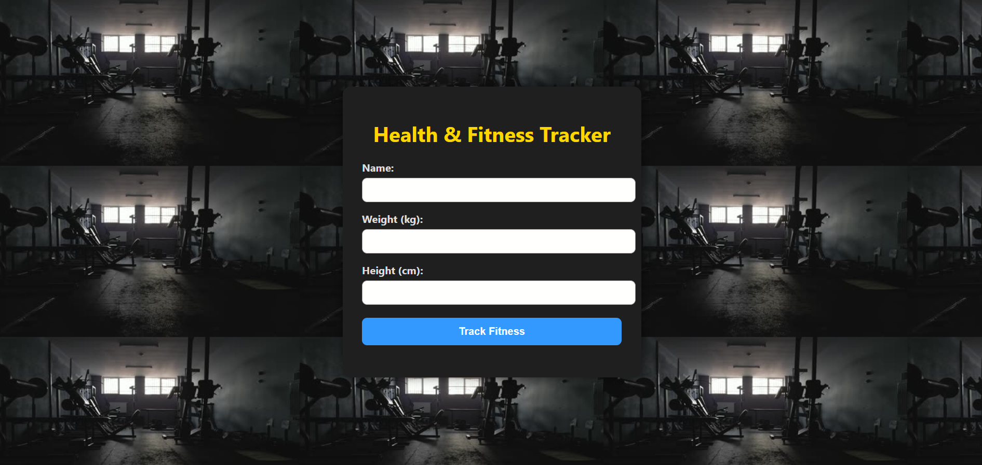
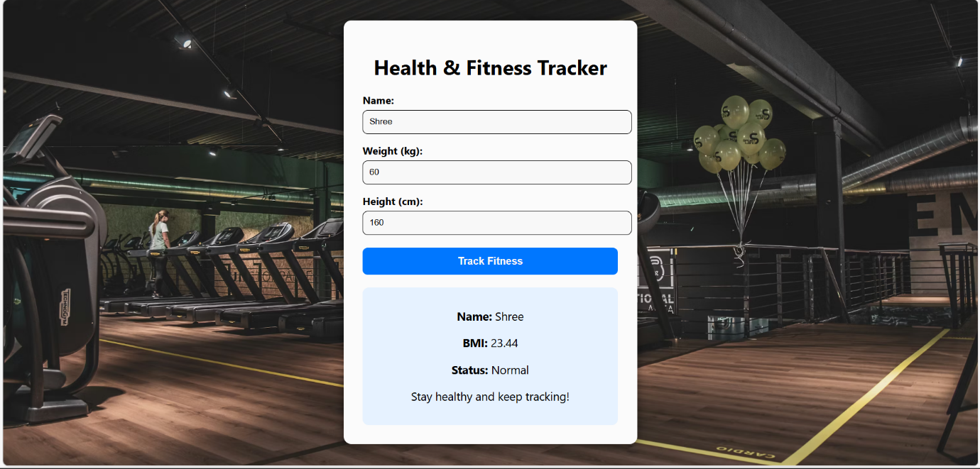

RESULT:
A Servlet is created to demonstrate the difference between HTTP GET and POST methods by creating a form and handling requests accordingly.

